LTspice Analysis of a Step-Down Switching Regulator

(9/05/2024)
Contents
Introduction 1
Specifications 1
Suggested Procedure 2
Calculations and Component Selection 3
Setting the Output Voltage 4
Setting the Switching Frequency 5
Inductor Selection and Maximum Output Current 5
Selecting the Input Capacitor 6
Selecting the Output Capacitor 6
Selecting the Catch Diode 7
LTspice Simulations 7
Startup Simulation 7
Efficiency Simulation 9
Project Report 11
Project Report Grading Rubric 13

Introduction
Our ECEN 390 project is to design and simulate a Step-Down Switching Regulator to convert the 14 to 24 V DC output from a solar panel to a DC output voltage within the range of 3.0 to 10 V, utilizing the LT3971A Integrated Circuit (IC) step down switching regulator. You are to choose the desired DC output voltage for your design, which is to provide a maximum guaranteed DC output current of 1.0 A. LTspice is to be used to characterize the performance of your DC-to-DC converter. Each person is to individually design and simulate their own DC-to-DC converter, along with writing a project report. For this project 20% of your grade is determined by the submission of the document Switching Regulator Component Selection Summary, with the remaining 80% determined by a Project Report, as described in the appropriate DC Power Supply Project Instructions.

Specifications
As previously mentioned, you are to choose the fixed output voltage from your switching regulator, within a 3.0 to 10.0 V range. Key performance specifications of this DC Power Supply project are as follows:

- 14 to 24 V Input Voltage Range.
- Your Choice of DC Output Voltage within a 3.0 to 10.0 V range.
- Maximum DC Output Current of 1 A.
- Efficiency of your Power Converter @ V_{in} = 18 V.
The parts for this project are to be found in the available LTspice libraries. Download the LT3971A Demo Circuit from www.analog.com, and save this LTspice circuit as a starting point for your specific design. If your version of LTspice does not recognize the LT3971A, please update your LTspice with the “Sync Release” command in the Tools menu.

Suggested Procedure
The following is the suggested procedure for designing your DC Power Supply, remembering that “You don’t have time to rush”.

- Become familiar with the Table of Contents of this document, as most project questions asked by students are answered in this document. Using Ctrl + Click allows you to easily navigate this document from the table of contents.
- Navigate to the LTspice LT3971A Demo Circuit from www.analog.com, and save this circuit locally as a starting point for your specific design. If your version of LTspice does not recognize the LT3971A, please update your LTspice with the “Sync Release” command in the Tools menu.
- Modify the downloaded demo circuit to look like the circuit shown in Figure 1 below, including net labels for Vin, Vsw, Vboost and Vout. Note: Component names are different in Figure 1, than in the Demo Circuit version, so go with component names in Figure 1.
- Choose your desired output voltage within the range of 3.0 V ≤ V_{out} ≤ 10.0 V.
- Based on the following instructions, determine the following values for your schematic: R1 and R2, L1, C_{out}, and D1, along with the other calculations indicated in the instructions below.
- Complete the Switching Regulator Component Selection Summary.docx, including your calculations, and submit your results to Canvas. It is recommended that you check your results with the calcCheck_Student.m MATLAB script before submitting and proceeding with your design.
- Modify your schematic from the downloaded LTspice LT3971A Demo Circuit to remove unrelated documentation from the demo circuit, then include your name and selected component values for R1, R2, Rt, L1, C_{in}, C_{out} and D1.
- Characterize your resulting Switching Power Supply circuit as outlined in the LTspice Simulation section of this document.
- Write and submit your project report after reviewing the Project Report Grading Rubric at the end of this document.

Calculations and Component Selection

A step-down switching regulator using the LT3971A switching regulator Integrated Circuit (IC) is to be designed and simulated using LTspice. The LT3971A circuit illustrated in Figure 1 below, is to convert from a 14 to 24 V output from a solar panel to an output voltage of your choice ranging from 3.0 to 10 V, with a maximum output current of 1.0 A. The LT3971A is a current-mode controlled step-down regulator with the switching frequency ranging from 200 kHz to 2 MHz, as determined by the external resistor R_{t}. The LT3971A switching regulator IC utilizes an internal 1.19 V voltage reference, along with an external voltage divider to set the regulated output voltage.
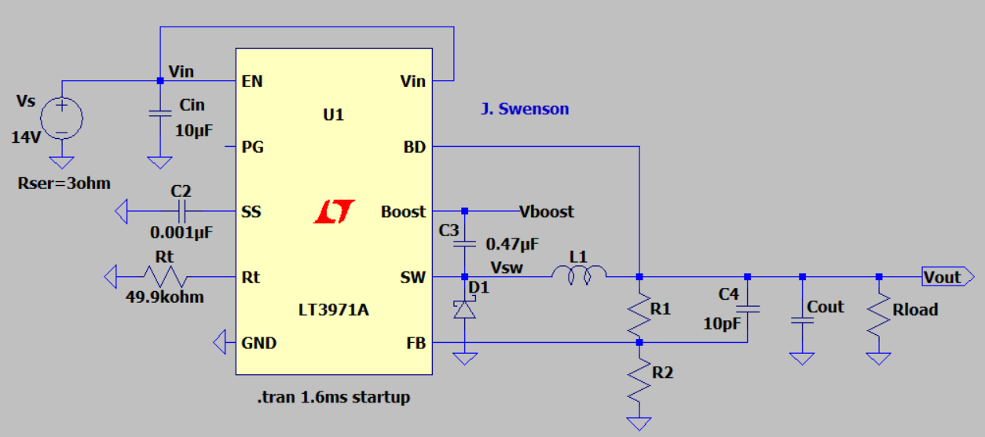

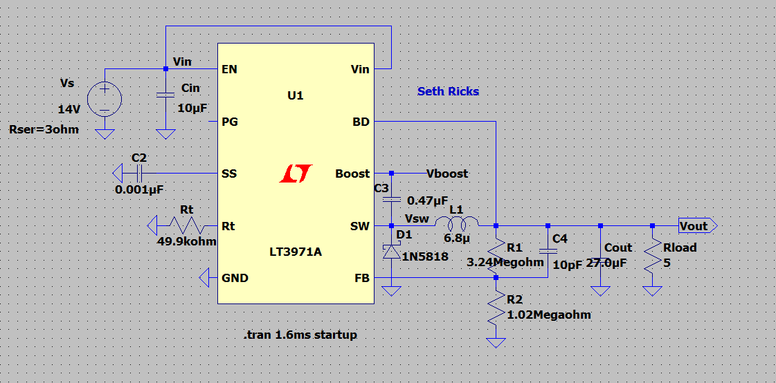
Figure 1: Schematic Diagram of the LT3971A Step-Down Switching Regulator.

Switching regulators are power converters that ideally provide the same output power to a load as the input power to the regulator. Consequently, for a given output power, a switching regulator requires more input current as the applied input voltage is lowered. This results in power-up challenges when the voltage supply for a switching regulator is first turned on. A switching regulator trying to regulate the output voltage when the input voltage is first turned on can demand excessive input current that may prevent the voltage supply from ever being able to ramp the output up to the desired input voltage. This is especially problematic for current limited supplies, such as solar panels. With such current limited supplies, when the input voltage is near zero and trying to increase the excessive input current demands of the switching regulator may result in the input voltage becoming stuck in a current limited, low output voltage state indefinitely. Yet the input current demands of a switching regulator decrease with increasing input voltage. So if a current limited supply were allowed to ramp up to a voltage near the desired input voltage before enabling a switching regulator, then this power-up problem could be avoided. As a result, a feature called soft start is incorporated into many switching regulator ICs that disable the switching regulator temporarily during power up to give the associated input voltage supply sufficient power-up time prior to enabling the switching regulator. The LT3971A switching regulator IC incorporates a user controlled soft start by means of an external capacitor and resistor connected to the Soft Start (SS) pin.

The LT3971A utilizes an internal npn bipolar junction transistor as the switch in a step-down (buck) converter topology. This npn transistor switches on and off the applied input voltage to an inductor and catch diode of a step-down transistor. It is desirable to minimize the collector-to-emitter voltage of this switching transistor to minimize power dissipation in the transistor. Consequently, the desired operational region for the switching transistor is “saturation” when the transistor is turned on. However, a base voltage greater than the applied input voltage is necessary to bias the npn switching transistor into saturation. The LT3971A utilizes the Boost function to generate a base voltage that is greater than the applied input voltage to achieve transistor saturation. The Boost circuit consists of an external capacitor and internal Schottky diode, with the capacitor connected between the switch (SW) and Boost pins as illustrated in Figure 1, resulting in a voltage V_{boost} that is larger than the applied input voltage.

The LT3971A is a current-mode switching regulator controller, meaning that a maximum switch current limit is implemented within the LT3971A IC by means of an internal sense resistor and comparator that turns off the npn switching transistor whenever the maximum switch current limit is reached. According to the LT3871A data sheet the internal switch current limit value ranges from 2.0 A to 3.2 A, with 2.5 A being a typical value.

The LT3971A achieves very low quiescent current by means of Burst Mode operation when the load current is less than approximately 100 mA. In Burst Mode the switching frequency drops from the user programmed constant frequency to switching only on demand as determined by the output voltage control circuitry.

See the LT3971A data sheet for more complete details.

Setting the Output Voltage

The output voltage of your step-down regulator is programmed by means of a resistive divider from the output to the Feedback (FB) pin of the LT3971A. The LT3971A circuity utilizes negative feedback to maintain the voltage at the FB pin at 1.19 V when the output voltage is within regulation. Hence, the desired output voltage equals the following:

$$V_{out}=V_{FB}\frac{R1+R2}{R2}$$

Solving for resistors R1 and R2 results in the following:

$$R1=R2\left(\frac{V_{out}}{1.19 V}-1\right)$$

For a practical low quiescent current design, choose 1.6 MΩ ≤ R1 + R2 ≤ 10 MΩ. Total resistance values > 10 MΩ become susceptible to errors due to small leakage currents. Also include a 10 pf capacitor in parallel with voltage divider resistor R1. Using standard 1% resistor values, determine the resistor values R1 and R2 necessary to provide the desired output voltage for your design within a tolerance of ±1%. (It is not necessary to select a specific manufacturer when entering your resistor values into LTspice, rather just enter the generic resistor symbol and then change the Resistance value to your chosen standard value.) The following values are standard 1% resistor numerical values per decade of resistor values:

10.0 | 10.2 | 10.5 | 10.7 | 11.0 | 11.3 | 11.5 | 11.8 | 12.1 | 12.4 | 12.7 | 13.0
13.3 | 13.7 | 14.0 | 14.3 | 14.7 | 15.0 | 15.4 | 15.8 | 16.2 | 16.5 | 16.9 | 17.4
17.8 | 18.2 | 18.7 | 19.1 | 19.6 | 20.0 | 20.5 | 21.0 | 21.5 | 22.1 | 22.6 | 23.2
23.7 | 24.3 | 24.9 | 25.5 | 26.1 | 26.7 | 27.4 | 28.0 | 28.7 | 29.4 | 30.1 | 30.9
31.6 | 32.4 | 33.2 | 34.0 | 34.8 | 35.7 | 36.5 | 37.4 | 38.3 | 39.2 | 40.2 | 41.2
42.2 | 43.2 | 44.2 | 45.3 | 46.4 | 47.5 | 48.7 | 49.9 | 51.1 | 52.3 | 53.6 | 54.9
56.2 | 57.6 | 59.0 | 60.4 | 61.9 | 63.4 | 64.9 | 66.5 | 68.1 | 69.8 | 71.5 | 73.2
75.0 | 76.8 | 78.7 | 80.6 | 82.5 | 84.5 | 86.6 | 88.7 | 90.9 | 93.1 | 95.3 | 97.6

For example, 1.00 Ω, 10.0 Ω, 100 Ω, 1.00 kΩ, 10.0 kΩ, 100 kΩ, etc., are standard 1% values.

Setting the Switching Frequency

Choose Rt = 49.9 kΩ_1%, for a switching frequency of 800 kHz. (It is not necessary to select a specific manufacturer when entering your resistor values into LTspice, rather just enter the generic resistor symbol and then change the Resistance value to your chosen standard value.)

Inductor Selection and Maximum Output Current

Use the following equation to arrive at an approximate inductor value, assuming the Schottky diode voltage drop V_{D} = 0.5 V.

$$L=\frac{V_{out} + V_{D}}{f_{sw}}$$

Your calculated inductance value should be < 15 µH.

A conservative approach regarding the maximum inductor current is to choose a peak inductor current ≥ 2 A, so as to avoid inductor saturation for load currents of ≤ 1 A. This can be done by typing in your calculated inductor value in the Inductor Parameter pane in LTspice, then clicking on Select Inductor. Next sort the list by Ipk[A] by left clicking on that column and then scroll through the listed inductors with 2.000 A peak current, choosing one that has an inductance value reasonably close to your calculated value. If you can’t find a 2.0 A peak current inductor of value reasonably close to your calculated value, then click on the List All Inductors in Database button which greatly increases the number of available inductor values.

Include your inductor calculations, along with the inductor model number, inductance value and peak current that you choose, in your LT3971A Component Selection Summary submission.

Selecting the Input Capacitor

Choose an input capacitor C_{in} of 10 µF. (It is not necessary to select a specific manufacturer when entering your capacitor values into LTspice, rather just enter the generic capacitor symbol and then change the Capacitance value to your chosen standard value.)

Selecting the Output Capacitor

Using the following calculation determine the minimum value of output capacitor C_{out} for your design.

$$C_{out} =\frac{100}{{V_{out}f}_{sw}}$$

Utilizing standard 10% capacitor values, choose an output capacitor that is greater than or equal to your calculated value, but not to exceed the next larger standard value size. Standard 10% capacitor values, which are limited to the following numerical values per decade of capacitor values: 10, 12, 15, 18, 22, 27, 33, 39, 47, 56, 68, and 82. (It is not necessary to select a specific manufacturer when entering your capacitor values into LTspice, rather just enter the generic capacitor symbol and then change the Capacitance value to your chosen standard value.)

Selecting the Catch Diode

A Schottky diode is necessary for the catch diode D1 for fast switching along with lower forward voltage drop. The Peak Reverse Voltage for the Schottky diode should be at least 30 V for the 24 V maximum input voltage. Choosing a catch diode with Peak Reverse Voltage much larger than 30 V results in poorer power efficiency, as the forward voltage of diodes increases some with increasing Peak Reverse Voltage. The average forward current of the Schottky catch diode is to be calculated as follows, where 1 A is to be used for I_{out}:

$$I_{D_Avg}= I_{out}\frac{V_{in_max}-V_{out}}{V_{in_max}}$$

After calculating the average forward current for the Schottky diode of your design, hover the mouse over diode D1 and then right click to open the Diode parameter pane. Then choose Pick New Diode and select a Schottky diode from the available list having an average current greater than or equal to your calculated value along with a reverse voltage of at least 30 V. (Note: Choosing a maximum reverse voltage that is > 50 V is not recommended for this design, as the diode forward voltage increases with increasing reverse voltage, which decreases efficiency.) Include your catch diode calculations along with the diode model number, average current value and peak reverse voltage that you choose, in your LT3971A Component Selection Summary submission.

LTspice Simulations

Startup Simulation

Referring to Figure 1, modify the input voltage source V_{s} to equal the 14 V minimum, which is the worst case for startup. Also modify the voltage source V_{s} to have a series resistance of 3 Ω, which can be done by hovering the mouse pointer over the voltage source V_{s} followed by a right click to open the Voltage Source configuration pane and setting the Series Resistance value to 3ohm. A non-zero output resistance of the voltage source makes start-up more difficult. Then include the following simulation command .tran 1.6 ms startup with the modifier startup accomplishing the following:
startup: Solve the initial operating point with independent voltage and current sources turned off. Then start the transient analysis and turn these sources on in the first 20 us of the simulation.
Increase or decrease the 1.6 ms transient analysis simulation time as necessary for your specific design. Also increase the value of the soft-start capacitor C2 if necessary for proper startup of your circuit. Calculate a value of R_{load} that results in 1 A of load current for your desired output voltage and then update your schematic for your calculated R_{load} value, using your exact calculated value for R_{load} rather than standard resistor values.

Run the simulation, and then select the traces V(vout), V(vin) and I(Rload)for plotting in the plot pane. Verify that your simulation circuit starts properly, which is indicated by your regulator output voltage achieving your desired output voltage, within a few percent because of resistor tolerances, while providing approximately 1 A of load current.

Note: LTspice uses a dark background for the default plot pane, which makes it hard to visibly see some trace colors such as dark blue. The Tools Control Panel Waveforms Color Scheme Selected Item: Background allows you to modify the background color with Red = Green = Blue = 255 resulting in a white background. This is an optional change that you may find improves waveform viewing. If you make this change, it is also recommended to navigate to Tools Control Panel Waveforms and change the Data Trace and Cursor width from 2 to 3, along with using a Bold Font for the waveform labels so that the traces, cursors are waveform labels are more easily visualized.

Add your name to plot pane, which can be added by means of the Plot Settings Notes and Annotations Place Text in the Plot Window top toolbar. Then include a plot of your start-up simulation results for your report, with a figure number and caption like the plot shown below in Figure 2.
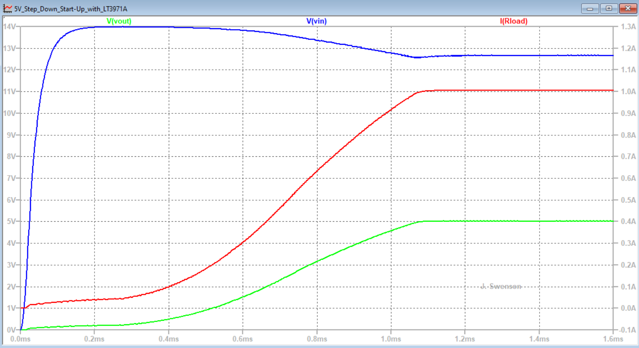

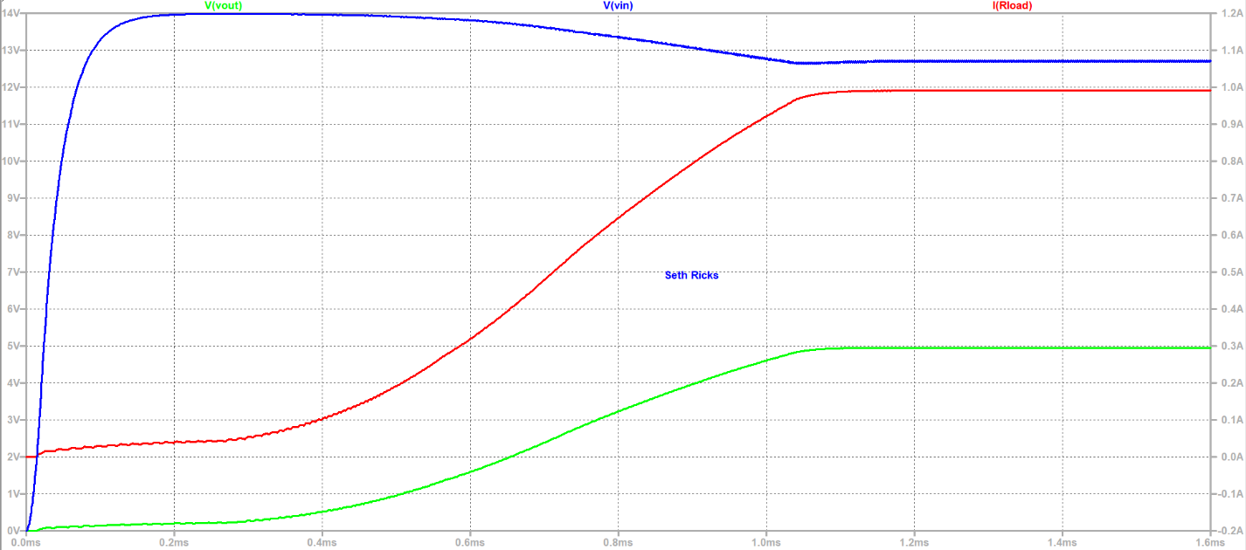
Figure 2: Start-Up Simulation Results of the Step-Down Switching Regulator.

Efficiency Simulation
As previously mentioned, switching voltage regulators offer much better power efficiency than linear voltage regulators, because the transistor switch or switches are operated either off or fully-on, both of which dissipate little power. LTspice provides an efficiency report feature that determines the overall power efficiency, along with the power dissipation of individual components of a switching regulator.

Note: The LTspice version for the Mac OS does not support the Efficiency Report feature for determining the power efficiency of switching regulators.

Include the following simulation command .tran 1.6 ms steady with the modifier steady accomplishing the following:
steady: Stop the simulation when steady state has been reached.
The LTspice efficiency report requires that the modifier steady be added to the .tran simulation command. The power efficiency is then calculated based on the steady state simulation results.
Change the voltage source V_{s} voltage from 14 V to 18 V, which is a nominal solar panel output voltage, and set the series resistance of the voltage source from 3 Ω back to 0 Ω prior to running your efficiency simulation. Run the simulation, and then select View Efficiency Report, followed by checking the box to Show on Schematic, to update your schematic with your efficiency report. Include your schematic with the efficiency report along with your name and a figure number and caption, like the plot shown below in Figure 3, in your report. For a properly functioning LT3971A step-down regulator, the efficiency should be on the order of 80% to 95%. 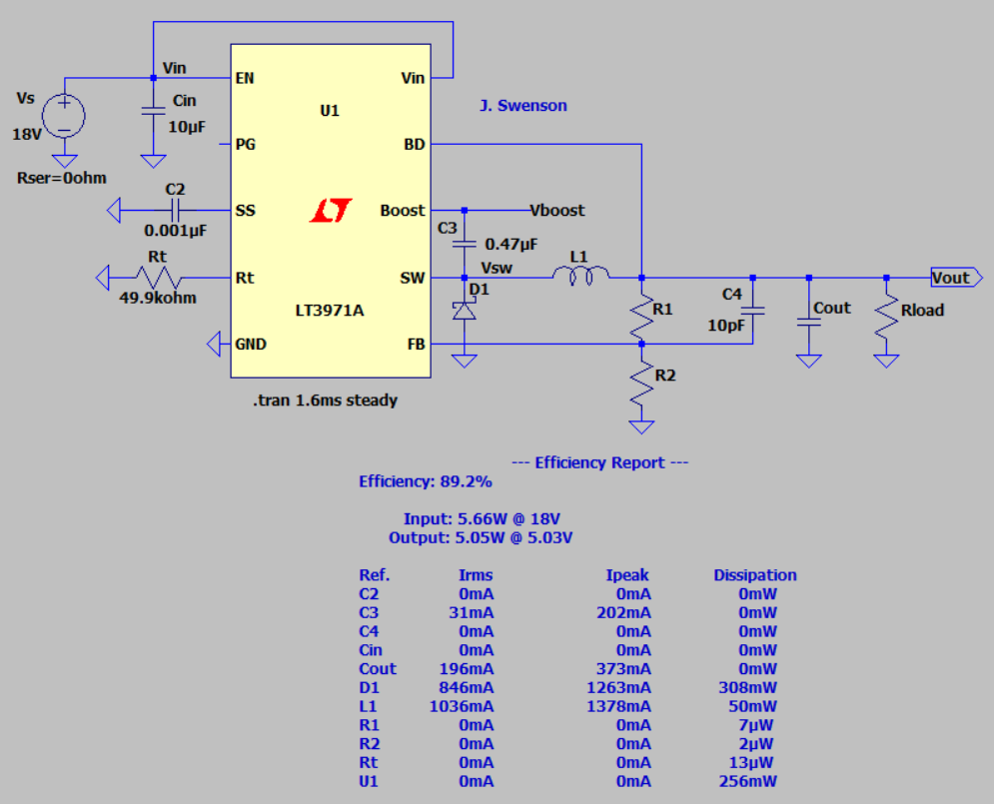
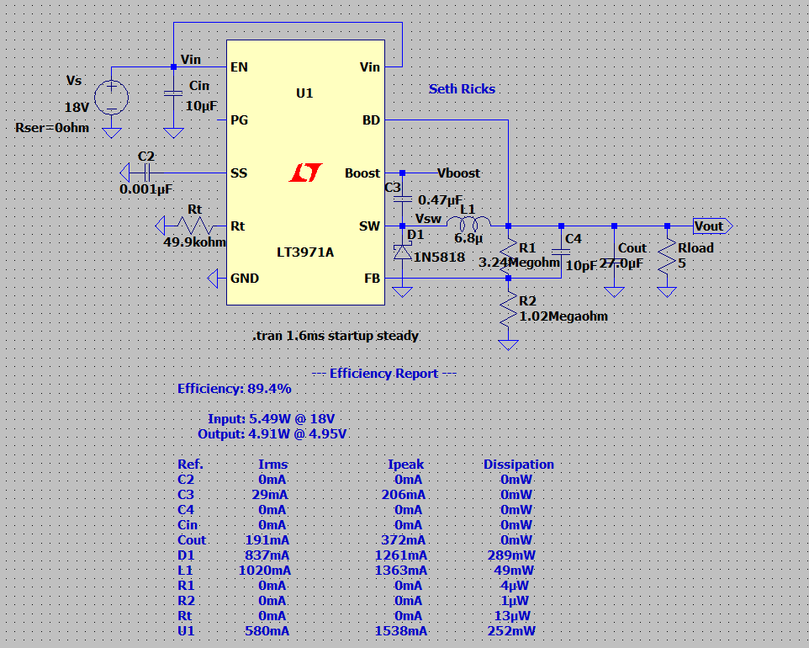Figure 3: Steady-State Simulation Results along with an Efficiency Report of the Step-Down Switching Regulator.
Based on your efficiency report values fill in the following table of values, with I_{in} and I_{out} to be calculated by means of the appropriate Power and Voltage, i.e., I = P/V. Also, the overall efficiency displayed on your schematic is to be used as the efficiency specification given in the Introduction section of your report.

Table 1: Input and Output Voltage, Current and Power Values of Step-Down Regulator.
P_{in} | V_{in} | I_{in} | P_{out} | V_{out} | I_{out} | % Efficiency
5.49W | 18V | 305mA | 4.91W | 4.95V | 991.9mA | 89.4%
Next in the plot pane, select Plot Settings Add Plot Pane to have two separate plot panes. For the top plot pane select the voltage traces V(vsw) and V(vboost). For the bottom plot pane select the traces V(vout) and I(L1). For a properly functioning LT3971A step-down regulator, the V(vboost) trace should vary from approximately V_{out} – 0.3 V to V_{out} + 18 V, the V(sw) trace should vary from approximately -0.3 V to 18 V, the V(vout) trace should have a mean value of approximately V_{out} with < 20 mV peak-to-peak ripple, and the I(L1) trace should have a mean value of approximately 1.0 A with a minimum value > 0 A and a maximum value < 2 A. Add your name to plot pane, which can be added by means of the Plot Settings Notes and Annotations in the Plot Window top toolbar. Then include a plot of your steady-state simulation results for your report, with a figure number and caption like the plot shown below in Figure 4.
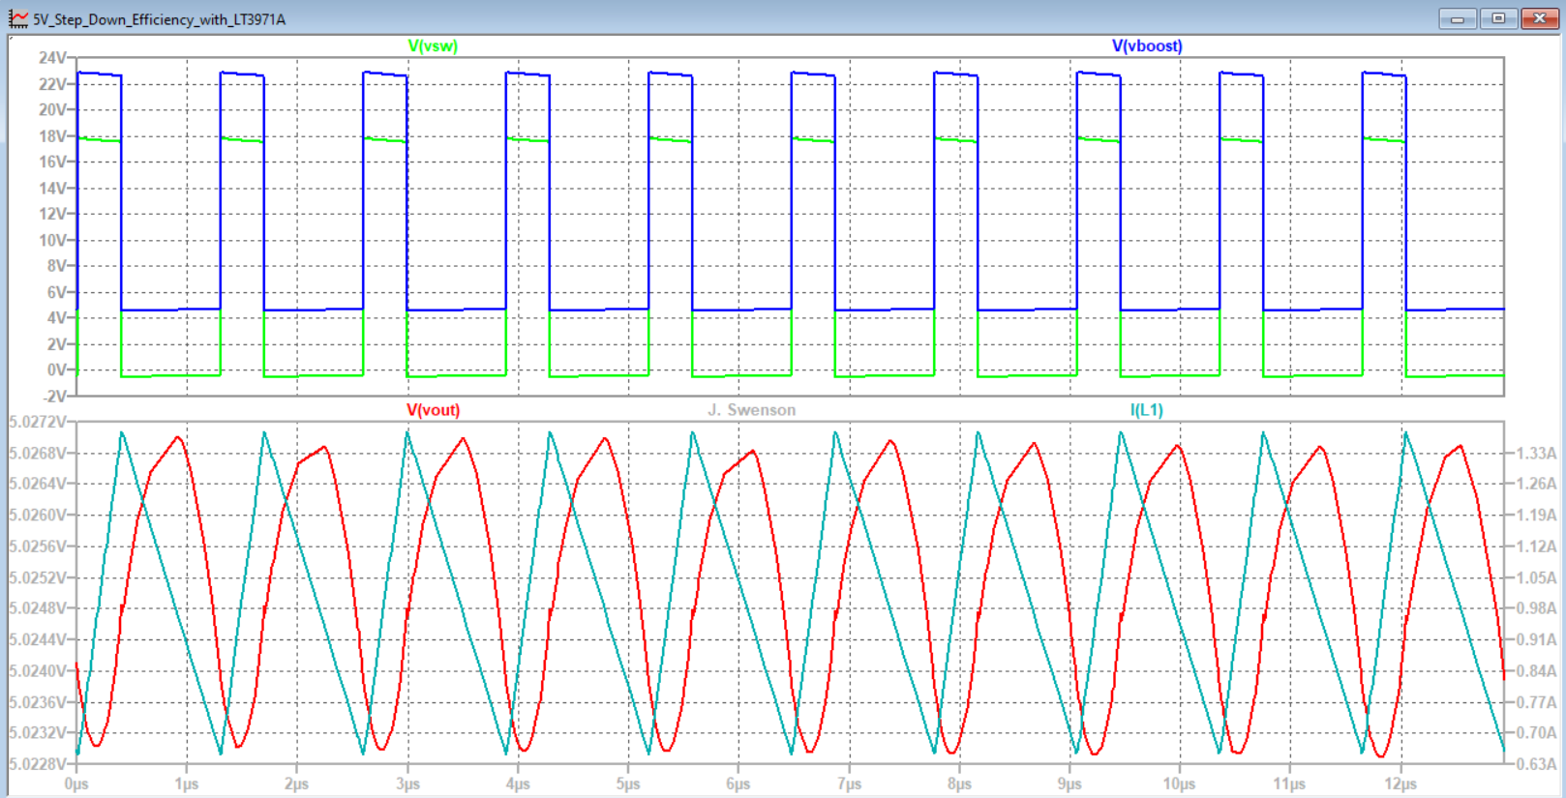

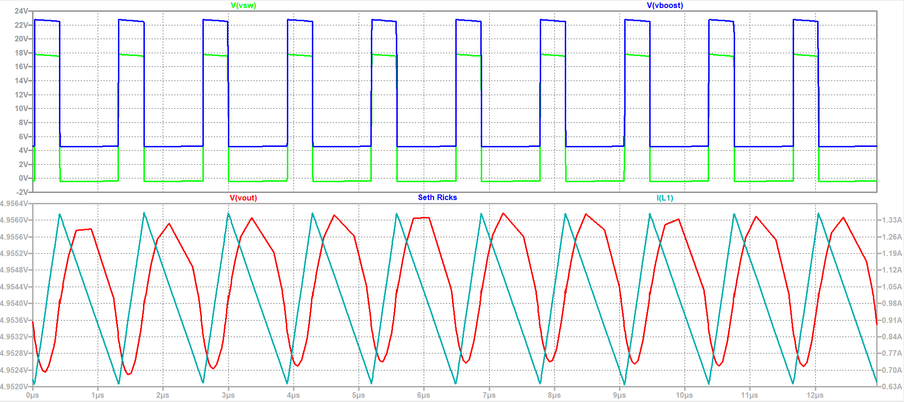
Figure 4: Steady-State Simulation Results of the Step-Down Switching Regulator.

Project Report

A future employer may very well read your project report as part of the hiring process, so write it with that end in mind. A good report will include all the sections mentioned below and will utilize figure and table numbers and captions along with complete and grammatically correct sentences with correct spelling and punctuation. Do not include explanatory text from this document or the grading rubric or bullet points from the grading rubric in your project report as that is not professional. Also, your component calculations do not need to be included in this report, rather focus on concise explanatory text of the items listed below and in the grading rubric.

Cover Page: Include class, Project title, and author.
Introduction: Introduce your project so that someone unfamiliar with this project can understand what it is you worked on. Include an introduction that consists of at least two sentences in addition to the following specified values for the power supply that you designed.

- Input Voltage Range.
- DC Output Voltage.
- Maximum DC Output Current.
- Simulated efficiency of your Power Converter @ V_{in} = 18 V.
Theory of Operation: Your Theory of Operation should include the following explanations in your own words:
- Description of the LT3971A IC including whether it is used to convert AC to DC or DC to DC, whether it is a step-up or step-down voltage regulator, whether voltage or current mode control is used, along with the type of switching transistor used. Also describe how the user sets the switching frequency. Furthermore, include an explanation of how a user sets the desired output voltage for the LT3971A, including mention of the feedback (FB) pin and internal voltage reference. Additionally, include an explanation of the LT3971A Boost and soft-start functions, and why they are beneficial to the performance of a switching regulator power converter.
Explaining how the various circuits of your project work in your own words is an opportunity to demonstrate your understanding of the various electronic circuits.

Your explanatory text is to be authored by you, and not a copy of someone else’s work, including explanatory text pulled from this document. Representing someone else’s work as your own is plagiarism and a violation of the Honor Code.

Your Theory of Operation section is also to include an LTspice schematic diagram of your complete circuit for the start-up simulation, including all component values chosen along with your name annotated to your schematic. Also include your name on all your LTspice schematics, using the Text option available in the Edit pull-down menu. All figures should include a figure number and caption. As previously mentioned, your component calculations do not need to be included in this report, rather focus on concise explanatory text of the items listed above and in the grading rubric.

Power Supply Performance: Include a section in your project report for Power Supply Performance that includes the following items:

- Start-up Simulation Plot Pane with 1 A load current.
- LTspice schematic diagram of your complete circuit for the steady-state efficiency simulation, including the Efficiency report on the schematic.
- Steady-State Simulation Plot Pane.
- Table 1: Input and Output Voltage, Current and Power Values of Step-Down Regulator.
Discussion and Conclusions: Include a section in your project report for Discussions and Conclusions that includes at least three sentences summarizing your simulated power supply project. Additionally, compare your simulated switching regulator efficiency to the theoretical efficiency of a Linear Voltage Regulator for your chosen output voltage value, given an input voltage of 18 V along with 1 A DC of output current.

Project Report Grading Rubric
Report Item | Points
Cover Page  - Include class, Project title, and author. | 1
Introduction  - Project introduction of at least two sentences. (4 points.)  - Specifications. Input Voltage Range (1 point), DC Output Voltage of your design (1 point), Maximum DC Output Current (1 point), Efficiency of your power converter @ V_{in} = 18 V. (1 point.) | 8
Theory of Operation (TOP):  - Description of the LT3971A IC. (4 points.)  - Setting the switching frequency. (2 points.)  - Setting of output voltage. (4 points.)  - Boost function. (4 points.)  - Soft-start function. (4 points.)  - Schematic diagram of your complete circuit including component values along with Figure Number and Caption along with your name. (8 points total for schematic or schematics, 5 points for complete schematic, 2 points for Figure number and captions, 1 point for name annotated on the schematic.) | 26
Switching Regulator Performance:  - Start-Up Simulation Plot. (6 points, 1 point for a reasonable V(vin) trace, 1 point for the V(vout) trace achieving the desired output voltage, 1 point for the I(Rload) achieving approximately 1 A of load current, 2 points for figure number and caption, 1 point for name on plot.)  - Schematic with Efficiency Report. (9 points, 1 point for V_{s} = 18 V and Rseries = 0 ohm. 5 points for efficiency report with reasonable values included on schematic, 2 points for figure number and caption, 1 point for name on plot.)  - Table 1: (8 points total, 1 point per reasonable value, -0.25 points per entry without units. 1 point for Table number and caption.)  - Steady-State Simulation Plot. (9 points, 1 point for a reasonable V(vboost) trace, 1 point for a reasonable V(sw) trace, 1 point for a reasonable V(vout) trace, 1 point for a reasonable I(L1) trace, 2 points for having 2 separate plot panes, 2 points for figure number and caption, 1 point for name on plot.) | 32
Discussion and Conclusions:  - At least 3 sentences summarizing the simulated power supply project. (6 points.) Efficiency comparison of your regulator with a linear voltage regulator at your designed for output voltage with an input voltage of 18 V. This requires calculation of the theoretical power efficiency of a linear voltage regulator given at 100(V_{out}/V_{in}). (3 points.) | 9
Grammar and Professionalism | 4
Total | 80

